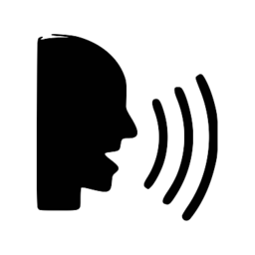FOOD

SPEAKING GUIDES

**What is your favorite food?**

My favorite food is… because…

**What kind of food you don’t like?**

I don’t like….because…

**What do you have for breakfast? / What did you have for breakfast yesterday?**

For breakfast I have…. / For breakfast I had….

**What do you have for lunch? / What did you have for lunch yesterday?**

For lunch I have… / For lunch I had….

**Which food group is your favorite?**

My favorite food group is…. Because….

**What did you have for your birthday last year?**

For my birthday I had…

**Do you prefer eating alone or in company?**

I prefer eating alone because….

I prefer eating in company because…

**Which is your favorite restaurant? / Where is it? / What do you eat when you go? When was the last time you went?**

My favorite restaurant is….. When I go I eat….

It is….. The last time I went was…

**Do you watch TV while you eat? / What do you watch?**

Yes, I do. I watch….

No I don’t, because…